Project 1

**Date Assigned: 11/02/2015**

**Lab Report Due: Midnight 11/09/2015 on iLearn**

**Section 1: Project Introduction**

We are going to make a **Tic-Tac-Toe game** using HTML, CSS, and Javascript.

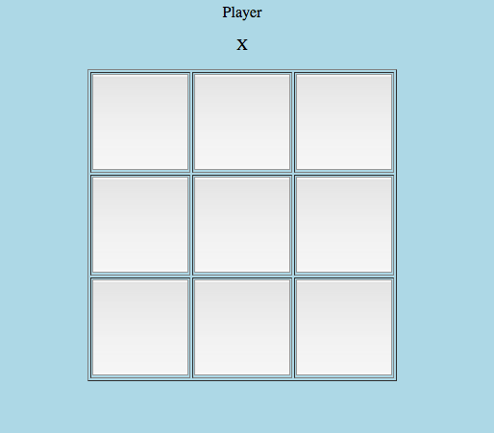

What is **Tic-Tac-Toe?**

Tic-tac-toe (also known as Noughts and crosses or Xs and Os) is a [paper-and-pencil game](https://en.wikipedia.org/wiki/Paper-and-pencil_game) for two players, X and O, who take turns marking the spaces in a 3×3 grid. The player who succeeds in placing three of their marks in a horizontal, vertical, or diagonal row wins the game. (From Wikipedia)

The Tic-Tac-Toe game we will make should be:

1. a two-player game
2. player “X” and “O” take turns to play the game (click on buttons)
3. game ends when either one player wins, or all buttons are clicked without a winner

**Section 2: HTML and CSS**

1. Create a folder **project1** on the desktop. Create two html pages **introduction.html,** and **tictactoe.html.** Save them in **project1**.
2. Create two CSS files **introduction.css,** and **tictactoe.css.** Save them in **project1**. Attach them to **introduction.html,** and **tictactoe.html**, respectively**.**
3. Add the following contents to **introduction.html**:
   1. A heading of “Welcome to Game Tic Tac Toe”
   2. Our course name “CMPT 120 Introduction to Programming” - in a different style than a)
   3. Your name “Author: yourname” (replace “yourname” by your name) - try it with different styles
   4. A mailto: link to send you e-mail (See textbook page 44)
   5. An introduction of the Tic Tac Toe game (You can copy section 1) - try it with different styles
   6. An anchor link “Click here to start the game!” that connects to **tictactoe.html**
4. Add the following contents to **tictactoe.html**:
   1. A heading of “Tic Tac Toe”
   2. A HTML form, in the form
      1. A paragraph that displays the current user. Initially the current user should be “X”(See the example code below). Give this paragraph an id “currentplayer”.
      2. A 3*3 table, where each table cell is a button. Give each button an id, e.g. for the button in the first row and first column, let its id be “0”, and for the button in the first row and second column, let its id be “1”. (See the example code below).
5. It’s time to be creative! Style **introduction.html** in introduction.css.
6. Style **tictactoe.html** in **tictactoe.css:**
   1. Let the **table** size be: height: 300px, and width: 300px
   2. Let the **button** size be: height: 100px and width: 100px
   3. Place the table in the center of web page (Google search how to center a table in CSS)
   4. Feel free to add more

<!DOCTYPE html>

<html>

<head>

<title> Example </title>

<meta charset = "utf-8">

<link rel="stylesheet" type="text/css" href = "example.css">

</head>

<body>

<form>

Current Player <p id="currentplayer">X</p>

<!-- Here is a 1*3 table with buttons. You need to modify the code to create a 3*3 table with buttons -->

<table border="1">

<tr>

<td><button type="button" id = "0" ></button></td>

<td><button type="button" id = "1" ></button></td>

<td><button type="button" id = "2" ></button></td>

</tr>

</table>

</form>

</body>

</html>

**TURN-IN CHECKLIST:**

1. **Source Code (.html/.css/.js files) created in this assignment. Remember to include your name, the date, and the lab number in comments near the beginning of your code.**

**Create a folder and name it 'FirstName_LastName_Project1'. In the newly created folder copy and paste your source code (.html/.css/.js). Then compress the folder, and upload it to iLearn.**